**Preliminary Float Plan**

**June 13-17**

**2017**

**Team 6392**

**La Loma Ward**

**Litchfield Park AZ**

**Grand Canyon Council**



**Introduction**

Varsity Team and Venturing Crew Members will be participating in a 30 plus mile kayak trip down the Verde River in Arizona. This trip will take place from June 13th to June 17th 2017. Kayak rentals and consulting is though South by Southwest Adventures LLC. Tour Leaders are Vern Wolfley and Greg Updike.

South by Southwest Adventures

11802 N 67th Ave, Glendale AZ 85304

551 N Main St, Cottonwood, AZ 86326

(623) 565-8432

(928) 421-1288

info@sbsouthwest.com

<http://sbsouthwest.com/>

**Trip Description**

Participating members will travel by private vehicle from the Church building in Litchfield Park to Lynx Lake in the Prescott National Forest, Tuesday (June 13th) afternoon. We will be camping and fishing here overnight, so we can get an early start Wednesday (June 14th) on the river. From Lynx Lake we will be traveling to South by Southwest Adventures office in Cottonwood to pick up our equipment and be shuttled to our launch location in Perkinsville. South by Southwest Adventures will be providing all of the boating equipment for this trip. This includes single or tandem inflatable kayaks, PFD’s for each participant, paddles, and dry bags if needed. All food, clothing and camping gear for this trip is the responsibility of the Team and Crew members.  Participants should be reasonably physically fit and prepared to get wet. All participants will be paddling and carrying their own boats and gear.

During the 4-day trip, participants will paddle down the Verde River a distance of approximately 30 miles. Our pick up point on day 4 is Tuzigoot Rd in Clarkdale. We will have some of our vehicles there ready to shuttle Leaders back to pick up the rest of the vehicles at the starting point. After the equipment is returned to South by Southwest Adventures members will then travel back to the Church building in Litchfield Park.

Cost for the trip is $150.00 per person at this time.

During our time on the water we will be exploring the Verde River area, discovering a whole new world while paddling down the waters of the Verde River. The Verde River is the only “wild” and “scenic” river in Arizona. **The Verde River is more of a big creek than a river,** with incredible wilderness of spectacular canyons, verdant forests, brightly colored wildflowers and a multitude of wildlife including mule deer, beaver, river otter, great blue herons, red tail hawks and golden and bald eagles.

We will be camping along the way each day providing opportunities to explore around the river and hiking to many different scenic areas. Daily activities will include paddles, hiking, exploring, napping, and fishing.

**Important Dates**

* May 3rd, 2017 Wednesday Night – Training Meeting with South by Southwest Adventure
* TBA - Planning meeting and updates
* TBA - Safety Afloat/Safe Swim training
* TBA - Swim Checks
* TBA - Planning meeting – bring all gear packed and ready to go for inspection
* TBA - Last call to South by Southwest Adventure to verify no last minute changes
* June 13th, 2017 – Leave for High Adventure
* June 17th, 2017 – Return from High Adventure

**Participants**

**Adult Leaders**

|  |  |  |  |  |
| --- | --- | --- | --- | --- |
| **Leader** | **Phone Number** | **Training/Expiration** | **Swim Check** | **Paid** |
| Vern Wolfley | (623) 764-4126 |  |  |  |
| Greg Updike |  |  |  |  |
| Bishop Webster |  |  |  |  |
|  |  |  |  |  |
|  |  |  |  |  |

**Varsity Team Members**

|  |  |  |  |  |
| --- | --- | --- | --- | --- |
| **Team Member** | **Phone Number** | **Training/Expiration** | **Swim Check** | **Paid** |
| Austin Curtis |  |  |  |  |
| Jared Curtis |  |  |  |  |
| Dylan Wirth |  |  |  |  |
| Erik Johnson |  |  |  |  |
| Levi Barrett |  |  |  |  |
| Tysho Tano |  |  |  |  |
|  |  |  |  |  |

**Venturing Crew Members**

|  |  |  |  |  |
| --- | --- | --- | --- | --- |
| **Crew Member** | **Phone Number** | **Training/Expiration** | **Swim Check** | **Paid** |
| Ryan Chou |  |  |  |  |
| Liam Curtis |  |  |  |  |
| Jacob Joyner |  |  |  |  |
| Joe Nickerson |  |  |  |  |
| Tyler Scherwinski |  |  |  |  |
| Daxton Wirth |  |  |  |  |
|  |  |  |  |  |
|  |  |  |  |  |
|  |  |  |  |  |

**Emergency Contacts**

|  |  |  |  |
| --- | --- | --- | --- |
| **Contact** | **Home Number** | **Cell Number** | **Other Number** |
|  |  |  |  |
|  |  |  |  |
|  |  |  |  |
| South by Southwest | (928) 421-1288 |  |  |
| Coconino County Sheriffs | (928) 774-4523 | 800-338-7888 | 911 |
| Yavapai County Sheriffs | (928) 771-3260 |  | 911 |
| Prescott National Forest | (928) 443-8000 |  |  |
| Coconino National Forest | (923) 527-3600 |  |  |

**Trip Itinerary**

|  |  |  |
| --- | --- | --- |
| **Date** | **Approximate Time** | **Description** |
| Tues - June 13 | 1pm | Depart from Church in Litchfield Park |
| Tues - June 13 | 3pm | Arrive at Lynx Lake to camp for the night |
| Wed – June 14 | 6am | Revile, breakfast, break camp |
| Wed – June 14 | 8am | Leave for Southwest by Southwest Adventures |
| Wed – June 14 | 9am | Arrive at Southwest by Southwest Adventures |
|  |  |  |
|  |  |  |
|  |  |  |
| Thru – June 15 | 7am | Revile, breakfast, break camp |
| Thru – June 15 | 9am | On the river |
|  |  |  |
|  |  |  |
|  |  |  |
| Fri –June 16 | 7am | Revile, breakfast, break camp |
| Fri –June 16 | 9am | On the river |
|  |  |  |
|  |  |  |
| Sat – June 17 | 7am | Revile, breakfast, break camp |
| Sat – June 17 | 9am | On the river |
|  |  |  |
|  |  |  |
|  |  |  |
| Sat – June 17 | 1pm | Stop at Crusty’s Pizza in Camp Verde for lunch |
| Sat – June 17 | 5pm | Arrive back at Church in Litchfield Park, Parents pick up |

**Team and Crew Requirements**

1. Attend all Pre-Trip meetings
2. Good Physical Condition
3. Swimmer on BSA Check
4. Know and understand BSA Safety Afloat guidelines

**Adult Requirements**

1. BSA Youth Protection, BSA Safety Training
2. BSA Registered as either Leader, Committee Member or Merit Badge Counselor
3. Attend all Pre-Trip meetings
4. Good Physical Condition
5. Swimmer on BSA Check
6. Know and understand BSA Safety Afloat guidelines

**BSA Safety Afloat and Safe Swim Defense**

On this trip the members will be following the guidelines established in the BAS Safety Afloat and Safe

Swim Defense programs.

1. Qualified Supervision (SA & SSD): We have met this requirement of at least two trained supervisors over 21 years old (Vern, Greg ), and two trained in CPR (Vern, Greg). In addition, all of the Scouts participating have had recent CPR training and all have earned or are working on the lifesaving merit badge.
2. Physical Fitness (SA & SSD): All Scouts and adults will have current medicals.
3. Swimming Ability, Ability Groups (SA & SSD): All Scouts and adults are swimmers. There will not be any non-swimmers or beginning swimmers on the trip. All Scouts have earned the swimming merit badge. All adults will pass the BSA swim test during the skills proficiency training.
4. Personal Flotation Equipment (SA): All PFD’s necessary are provided by South by Southwest Adventure. Spare PFD’s will be available in case one is damaged or lost on the river, or for use in a throwing rescue. During any swim time at a campsite, PFD’s will be worn by all in or near the water, including the lifeguards, because we will be swimming in on moving water.
5. Buddy System (SA & SSD): All Scouts will use the buddy system at all times when they are outside the area immediately around the campsite and at all times on the water. These boundaries will be determined and communicated when the campsite is setup. When on the water, each boat will also have a buddy boat. In the event of an odd number of boats or scouts, three will buddy together.
6. Skill Proficiency (SA): All participants will need to attend the training session that will be planned as necessary to provide the necessary skills training. Location and date are TBD. In addition to the training we will be reviewing the kayaking Merit Badge for more detailed information and skills review.
7. Planning (SA): This document contains the results of all the planning for this trip. It will be finalized by June 1st and copies distributed to all families of those participating and to the troop committee.
8. Equipment (SA): Most of the equipment is being provided by South by Southwest Adventure. This includes all boats, paddles and PFD’s. Ropes and rope throw bags will be used for lifesaving equipment while swimming.
9. Pre-swim exploration of swim area (SSD): A check of the swim area at a camp site will be performed by the group before any swimming is permitted.
10. Lifeguards (SSD): Because of the numbers in the group on this trip, we will not need more than two lifeguards at any time. Due to the location and logistics, poles for lifesaving will not be available (though other poles for lashing will be taken). Ropes from the troop bag will be used to implement the “line and tender” method. We also have two rope throw bags available.
11. Lookout (SSD): One of the adults will serve as the lookout. The location for the lookout will have to be made onsite.
12. Discipline (SA & SSD): Discipline will be enforced with the goals “safety first, fun second”. All adults will enforce this discipline for Scouts while on the trip. Adult discipline issues will be handled by committee as necessary.

**Personal Equipment List**

In June daytime temperatures range from mid 80’s to high 90’s. Temperatures in the 100’s are possible. Low humidity and perfect water temps for swimming make these summer days more comfortable. Nights cool off to pleasant high 50’s to mid 60’s.

**Pack**

You will not need to take a regular pack. Take a Day Pack and/or Fanny Pack for items you will need during the day. You will need a waterproof bag(s) for your gear. Wal-Mart has the Texsport yellow float bags for a very reasonable price. 22"x30" for $12.96 and 25"x43" for $24.96. The same bags at most outdoor specialty stores cost more.

We will not have lots of room for equipment so we need to pack light.

**Shelter**

Small Tent (small), Tarp or Ground Cloth, Long sand tent stakes, rope

**Sleeping Bag**

Sleeping Bag should be small and compact with a temperature rating of at least 20 degrees.

**Clothing**

You need to dress for desert conditions. Clothing helps reduce fluid loss, gives protection from sunburn, and is also a barrier against insect bites. Long sleeve shirts and pants give more protection from insects than T-shirts and shorts, and will help prevent sunburn during the day. Clothing should be light and loose fitting so there is a layer of insulating air. Sweating will then cool you more efficiently. A hat should be able to protect the head and the back of the neck. Limit the wear of sandals during the day, as they leave the top of the foot exposed. Sunscreen needs to be applied to exposed skin several times a day, especially after getting wet.

**First Aid**

The Group will have a comprehensive first aid kit available, but each person should plan to have a minimum personal first aid kit for themselves.

* Sunscreen (at least SPF 45+)
* Tweezers
* Sterile Gauze Pads
* Bandage Assortment
* Ace Bandage
* Pain Reliever
* Moleskin
* Insect Repellent
* Antibacterial
* Cleaning Pads
* Adhesive Tape
* Sunburn/Burn Cream/Aloe Vera Lotion
* Lip Balm
* Prescriptions, etc.

Know the signs of heat exhaustion! Dizziness and/or shallow breathing may be the first signs of heat exhaustion, and can be due to lack of body salt produced by excessive sweating, or not drinking enough water. It is essential that you drink plenty of water on this trip.

**Personal Gear Checklist**

**Clothing**

* Protection from bugs and sun – summer weight
* 2 long sleeved shirts
* 1 long pants
* 2 shorts
* 2 t-shirts (coolmax type material works best)
* Swim Wear
* 3 sets hiking socks
* Hiking Boots
* Jacket/Sweatshirt
* Water Shoes or Sandals
* Hat with visor for sun
* 2 bandannas
* 3 sets under garments

**Toiletries**

* Small Towel (shamy works well)
* Toilet Paper
* Tooth Brush/Paste
* Bio degradable soap
* Insect Repellent
* Clapstick
* Sunscreen 50+spf
* Any Personal Medication

**General**

* Sleeping Bag
* Sleeping Pad
* Dry Bags for packing
* Gloves
* Pocket Knife
* Headlamp/flashlight
* Extra batteries
* Sunglasses
* Water Bottle
* Plate/Bowl
* Cup
* Fork & Spoon
* Backpacking stove (if you have one)
* Rope
* Compass

**Fishing**

* License
* Rod
* Tackle
* Net

**Miscellaneous**

* Reading material
* Journal
* Pen
* Scriptures
* Camera
* Watch
* Hiking Stick

**Team and Crew Gear**

* Trash Bags
* First Aid Kits
* Fire Pan
* 3 Portable Stoves and Fuel
* Portable Shovel
* Hatched
* Ax
* Bow Saw
* Water Purifier
* Water Bag

**Traveling Gear**

Money for and food or snacks during car travel

Bag with Clean clothes to change into for the return trip (These will stay in the vehicles)

**Prohibited Items**

* Firearms, archery equipment, pellet or BB guns, slingshots, etc.
* Expensive or irreplaceable items that you do not want to get wet, dirty or broken – i.e., expensive camera or camcorder, etc.
* Electronics – Entertainment gadgets like cd players, tape player, game boys, etc.
* Anything that violates the values of Scouting or For the Strength of Youth
* Secret stash of food. All food needs to stay together and will be put in bear bags at night.
* Clothing with artwork or messages not consistent with Scouting values – e.g., shirts that promote tobacco, alcohol, drugs, or the Dallas Cowboys.

**Food**

Final food preparations will be determined during planning meetings. A meal schedule will be made ahead of time. Individuals are responsible for their own meals and planning, but may plan in groups. Dinner will be a community meal. Meals listed do not have to be made in the order given:

|  |  |
| --- | --- |
| Tuesday - June 13  (Day 1) | Breakfast: On your own  Lunch: On Your Own  Dinner: Group Meal |
| Wednesday - June 14  (Day 2) | Breakfast: Group Meal Quick  Lunch: Group Meal No-cooking (sandwiches)  Dinner: |
| Thursday - June 15  (Day 3) | Breakfast:  Lunch:  Dinner: |
| Friday - June 16  (Day 4) | Breakfast:  Lunch:  Dinner: |
| Saturday - June 17  (Day 5) | Breakfast:  Lunch:  Dinner: |

**Here are some ideas to think about:**

Camping Store Foods (REI, Sportsmans, etc.): Freeze-dried and dehydrated foods.

Pro: light, compact and nourishing.

Con: cost.

Grocery Store foods: With careful shopping, you can put together high-energy meals that weigh little more that camping store foods, and cost far less. Consider some of the following:

**Breakfast**

* Cold cereal (non-crushable)
* Hot cereal (individual serving packets)
* Granola (make your own)
* Dried fruit
* Instant hot chocolate
* Instant breakfast drink (add powdered milk)
* Pancake flour
* Powdered eggs
* Precooked bacon
* Canned meat

**Lunch**

* Power bars
* Crackers or sea biscuits
* Jerky
* Nuts
* Dried fruit
* Fruit drink mix
* Trail Snacks
* Granola bars
* “birdseed” (nuts, raisins, chocolate)
* Dried fruit
* Drink mix

**Dinner**

* Instant potatoes
* Quick-cook rice, noodles, macaroni
* Dried beef
* Canned tuna, chicken, ham
* Dried mixed vegetable flakes
* Soup mix
* Instant and/or quick-cook puddings
* Drink mix

**Ideas for Food Planning for the Day**

**Breakfast**

Crawl out of the tent at dawn, fire up the stove, and boil a pot of water. Use some of it for a hot drink, and some for quick-cook oatmeal. You can also add raisins, honey or sugar, powdered butter, and a little powdered milk. The remaining hot water goes for clean-up.

**Trail Snacks**

During the day, stop every once in a while for a handful of “birdseed” and a sip of water. The “birdseed” gives you a constant source of energy, while the water replenishes fluids.

**Lunch**

Find a nice overlook or shaded area for mid-day break. Have a Power bar, dried fruit and/or jerky. Wash it down with plenty of liquids.

**Dinner**

After pitching tents and making camp, heat water for instant soup or other instant meal. While it is warming, combine powdered milk and water with instant pudding mix and set it aside to firm up for dessert. (For quicker results, set the pot in shallow water at the edge of a cool stream). While sipping soup, start a pot of hot water for noodles, and add some dried beef, tuna, or bits of jerky. You can also add some dried mushrooms or other vegetables. Let it simmer a bit and then dig in. As you eat heat water for clean-up. Use sand or a scrub-pad to scour pots and utensils, and a little biodegradable soap to cut grease. Boiling water will kill any lingering germs. Scatter dirty dishwater over a wide area far from sources of fresh water.

**No-Cook meals**

To get an early start on the trail and to avoid lengthy stops for lunch, plan some meals that require no cooking.

**Repackaging food**

Most grocery store food is packaged in a way that takes up space. By disposing of the containers and wrappings, you can eliminate weight and a lot of bulk while organizing. Get a supply of plastic food storage bags of various sizes and divide your supplies into portions, each one large enough for one meal. Fill a bag with exactly the right amount of food to feed the crew. Mix in any appropriate additions (powdered milk, dried fruit, etc.). Before you close the bag, write cooking instructions on a slip of paper (or cut instructions from original container) and put that in too. You can then put all of the repackaged food for each meal into a larger bag and label them appropriately. Example: “Dinner – Day One”. That way you will know exactly what food you have, how to prepare it, and when to eat it.

**Extra Food**

We will pack some extra food in case of an emergency. These should be food that does not require cooking (jerky, dried fruit, granola bars, etc.). We may also have opportunities to gather some of our own food as well (fish, etc.)

Food will be packed into one day rations before the trip in waterproof containers (zip-locks).

**Waste Disposal and Campfires**

Waste Disposal - TBD

A fire pan is required for all wood and charcoal fires

**Low Impact Camping Rules and Regulations**

(Desert Etiquette)

1. Campfires must be contained in a fire pan.
2. Human waste (feces) MUST be containerized and carried out.
3. PACK OUT ALL TRASH including food scraps.
4. Do not swim in potholes or pollute side streams with soap and oils. Soap (preferably biodegradable) may be used in the river.
5. Purify all water before drinking.
6. When hiking away from the river use existing game or foot trails, slickrock or washes. Avoid walking on cryptogamic soils. (Cryptogamic soil is a thin crust made up of mosses, lichens, algae, and bacteria that make up a habitat referred as a cryptogram. It is found in unvegetated areas between shrubs, grasses, and flowering plants in undisturbed arid and semi-arid lands of the world. Cryptogams function as soil builders. They form a spongy layer that helps protect soil from erosion, absorbs moisture, and provides nitrogen and other nutrients for plant growth.
7. When large areas of the cryptogamic crust are disturbed, water and wind erode the soil. Detached pieces of crust have little chance for reattachment.)
8. COLLECTING ARTIFACTS of any type is AGAINST THE LAW. Do not disturb or deface natural features or archaeological sites.
9. Firearms, archery equipment, pellet or BB guns, slingshots, etc. are prohibited

**Safety Considerations**

1. Everyone will wear a life vest **AT ALL TIMES**. It is required by law that each person has a Type 3 life vest within reach.
2. To avoid the loss of equipment use of tie down lines or bungee cords to secure your gear inside the kayak at all times while kayaking.
3. A portable water vessel such as a bucket or pail is REQUIRED for bailing, settling river water or extinguishing campfires.
4. THE IMPORTANCE OF SECURING YOUR UNATTENDED BOAT CANNOT BE STRESSED ENOUGH.
5. When leaving a kayak unattended for any length of time ALWAYS tie it with bow and stern lines to a secure tree, rock or to a dead man anchor point. Check the security of all lines before going to bed. Where possible it is best to pull kayaks completely out of the water, even when taking short walks away from the river.
6. DO NOT KAYAK IN HIGH WIND CONDITIONS. MORE PARTIES CAPSIZE DUE TO KAYKING IN
7. HIGH WINDS THAN ANY OTHER SITUATION. If you are in a situation that leaves you no option then stay as near to the shoreline as possible otherwise go ashore for safety.
8. Due to the possibility of desert FLASH FLOODS exercise extreme caution when selecting a campsite in or near side canyons. NEVER camp or leave your canoe unattended in canyon drainage no matter how calm the weather may seem to be.
9. When camped on a sand bar it is recommended that you place your camp away from the water's edge a minimum of 10 ft. Choose a sand bar that is 2 ft. or more above water level. Fluctuations in water level in the main river channel of more than 1 ft. in an overnight period are very rare.
10. It is REQUIRED that you have a detailed river map in your possession at launch time. (We have two maps)
11. In the event of a medical emergency or other such problem during your trip continue on to a pick-up point. DO NOT ATTEMPT TO HIKE OUT FOR HELP. Seek out other kaykers for help and communication of your emergency to outside resources.
12. Be aware of all water and sun hazards. Swim at your own risk. Never jump or dive into the river. Wear shoes at all times while swimming or bathing. Protect yourself from the sun with suitable clothing. Sun glasses, hats and sun screen are advised.
13. The BUDDY SYSTEM will be used. Every person will have a buddy with them. Every kayak will have a buddy kayak as well.

**Fishing**

Fishing License – A valid Arizona fishing license is required for Arizona resident and non-resident anglers 10 years of age or older fishing any public accessible water in Arizona. Youth under the age of 10 and blind residents do not need to purchase a state fishing license to fish in Arizona. Check the [Arizona Fishing Regulations](https://www.azgfd.com/fishing/regulations) for additional information.

|  |  |  |
| --- | --- | --- |
| **Licenses** | **Privileges** | **Fee** |
| General Fishing | Allows the take of all fish species statewide, including at Community Fishing waters. | $37 |
| Combination Hunt and Fish | Allows take of all fish species statewide (including at Community Fishing waters), small game, fur-bearing animals, predatory animals, nongame animals, and upland game birds. | $57 |
| Youth Combination Hunt and Fish (ages 10–17) | Allows take of all fish species statewide (including at Community Fishing waters), small game, fur-bearing animals, predatory animals, nongame animals, migratory birds and upland game birds. | $5 |
| Community Fishing | Allows take of all fish species at Community Fishing waters | $24 |

Licenses are valid one year from date of purchase.

All licenses that allow fishing are valid for the take of trout and for simultaneous fishing with two poles or lines.

**Maps**

Map for Tuesday from Church to Lynx Lake

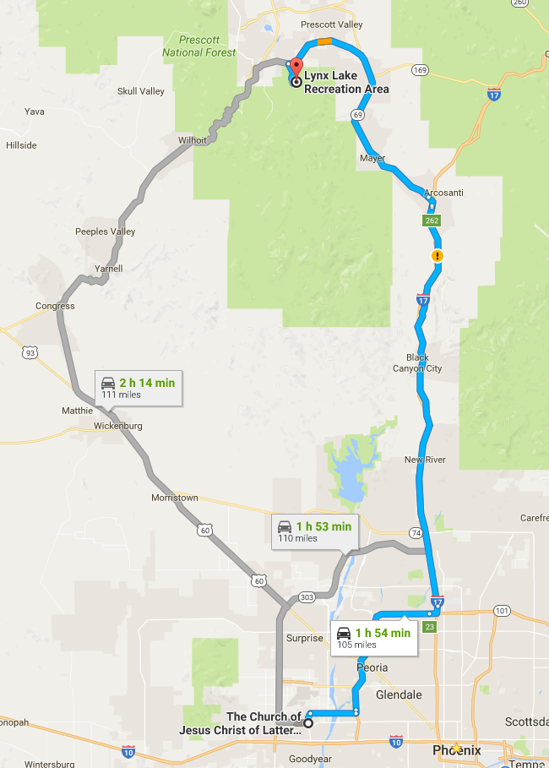

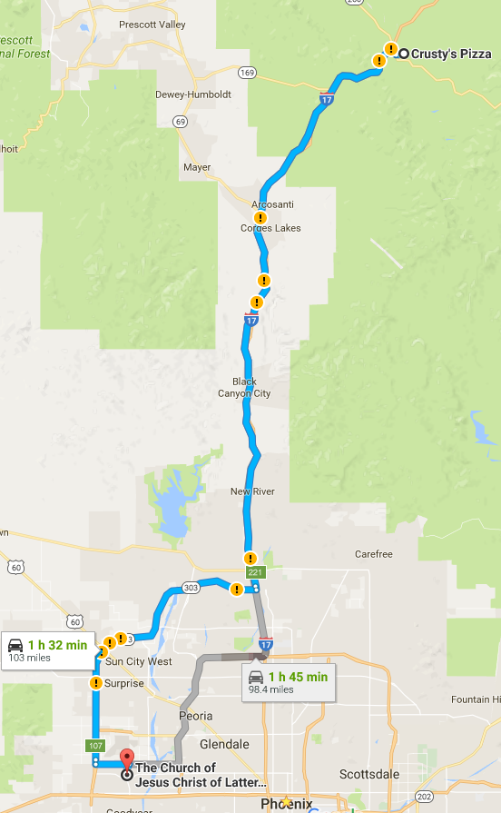Map for Saturday from Camp Verde to Home

**Personal Gear Checklist**

**Clothing**

* Protection from bugs and sun – summer weight
* 2 long sleeved shirts
* 1 long pants
* 2 shorts
* 2 t-shirts (coolmax type material works best)
* Swim Wear
* 3 sets hiking socks
* Hiking Boots
* Jacket/Sweatshirt
* Water Shoes or Sandals
* Hat with visor for sun
* 2 bandannas
* 3 sets under garments

**Toiletries**

* Small Towel (shamy works well)
* Toilet Paper
* Tooth Brush/Paste
* Bio degradable soap
* Insect Repellent
* Clapstick
* Sunscreen 50+spf
* Any Personal Medication

**General**

* Sleeping Bag
* Sleeping Pad
* Dry Bags for packing
* Gloves
* Pocket Knife
* Headlamp/flashlight
* Extra batteries
* Sunglasses
* Water Bottle
* Plate/Bowl
* Cup
* Fork & Spoon
* Backpacking stove (if you have one)
* Rope
* Compass

**Fishing**

* License
* Rod
* Tackle
* Net

**Miscellaneous**

* Reading material
* Journal
* Pen
* Scriptures
* Camera
* Watch
* Hiking Stick